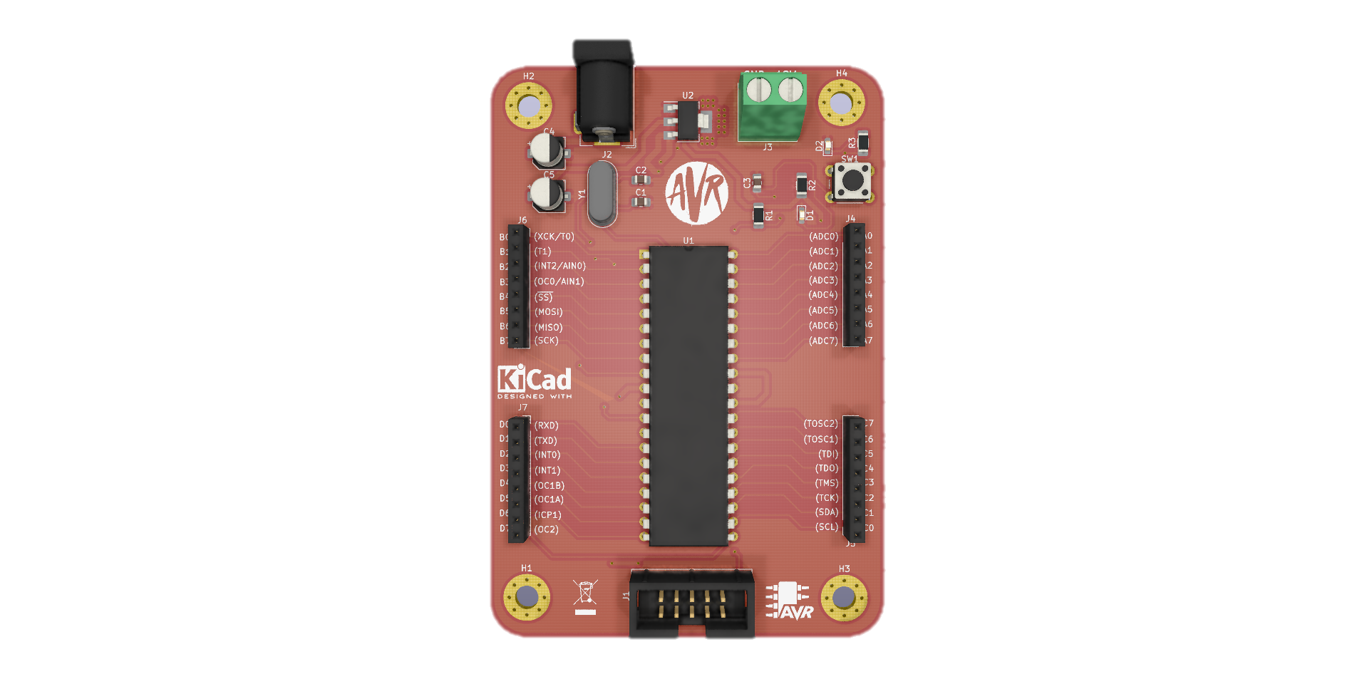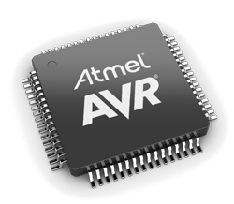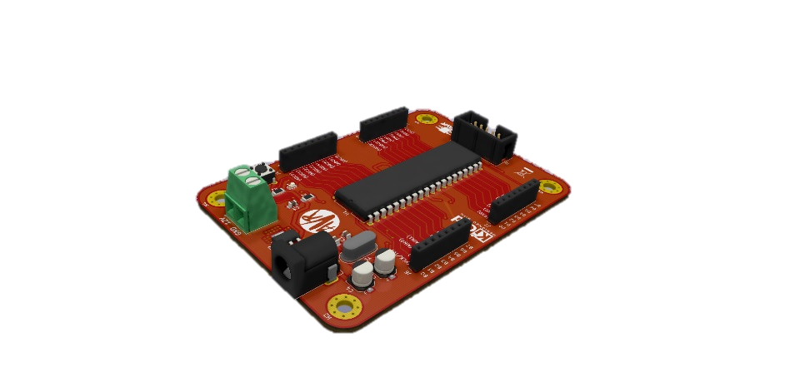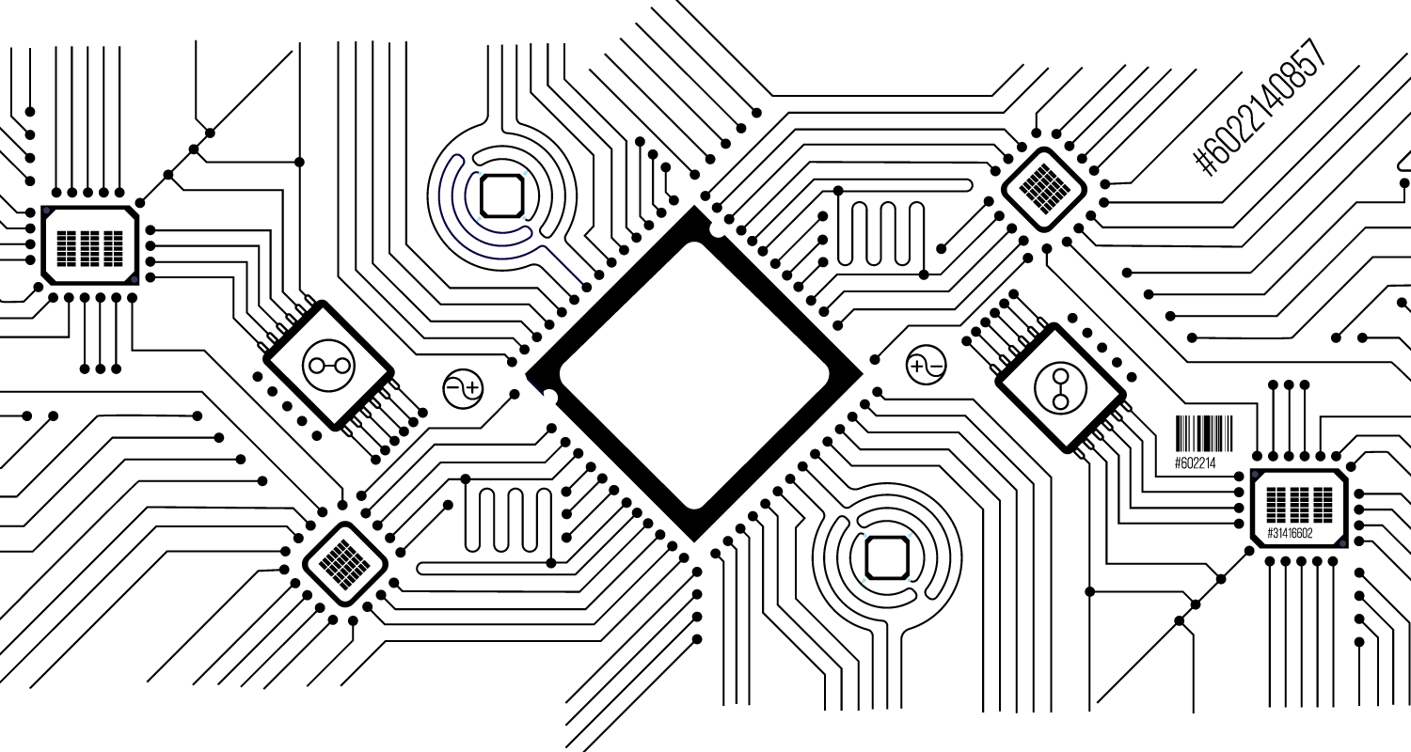

**SPECIFICATION OF THE AVR DEVELOPMENT BOARD**

* Low-Power 8-bit Microcontroller
* 32K Bytes Flash
* 2K Byte SRAM
* Data Retention: 100 years at 25OC
* Works up to 16MHz
* Operating Voltage 9V-25V
* Operating Current 1A-2A
* Internal Calibrated RC Oscillator
* External and Internal Interrupt Sources
* 32 I/O Pins

**PERIPHERAL FEATURES**

* Two 8-bit Timer/Counter
* One 16-bit Timer/Counter
* 8-channel, 10-bit ADC
* Programmable Serial USART
* Master/Slave SPI Serial Interface
* Programmable Watchdog Timer
* On-chip Analog Comparator

**am5020488@gmail.com**

**01554640964**

**NEW GENERATION OF DEVELOPMENT BOARD**